Pig file

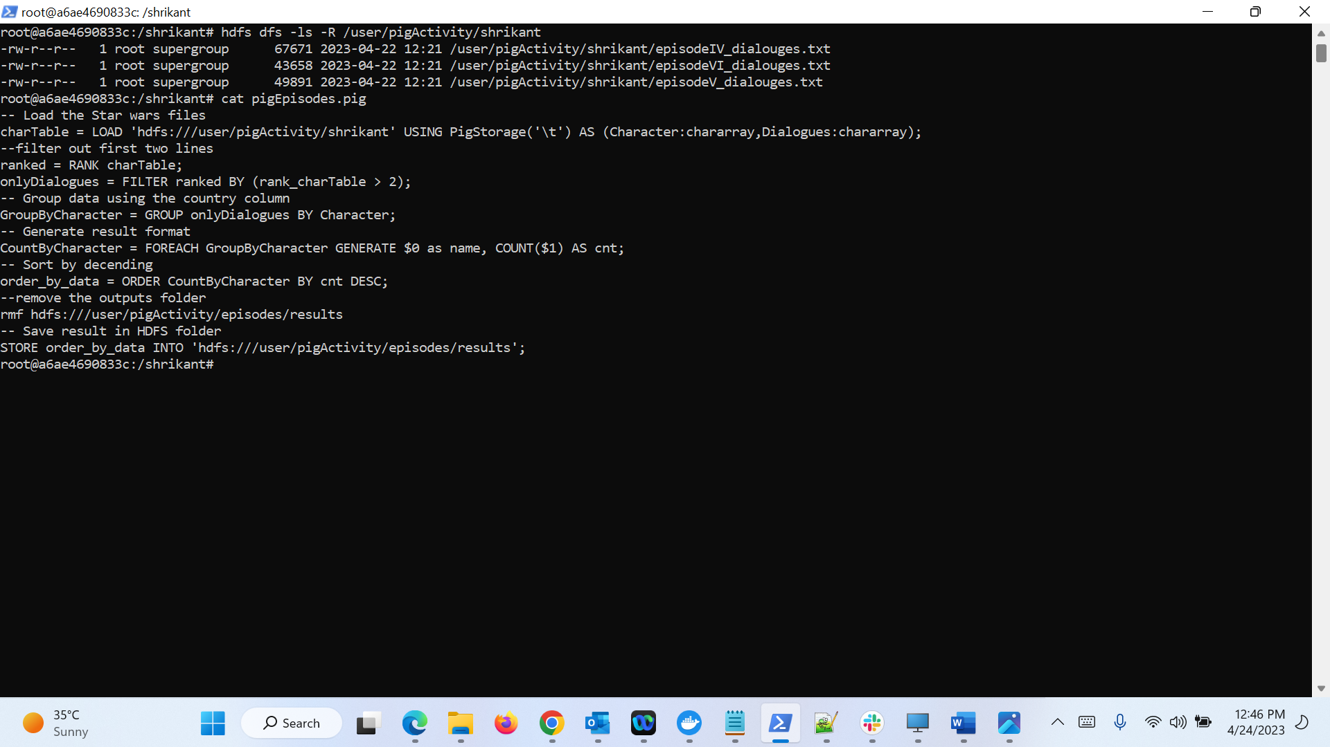

Result of episodes_dialouges in HDFS

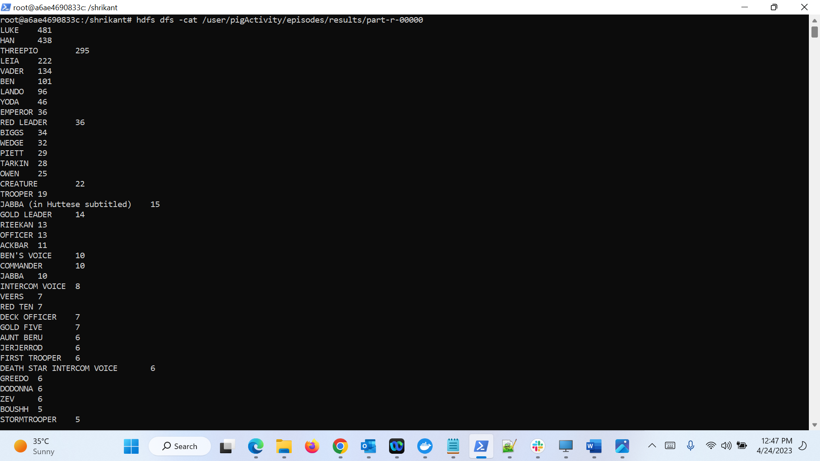

Result of episodeIV_dialouges in Local 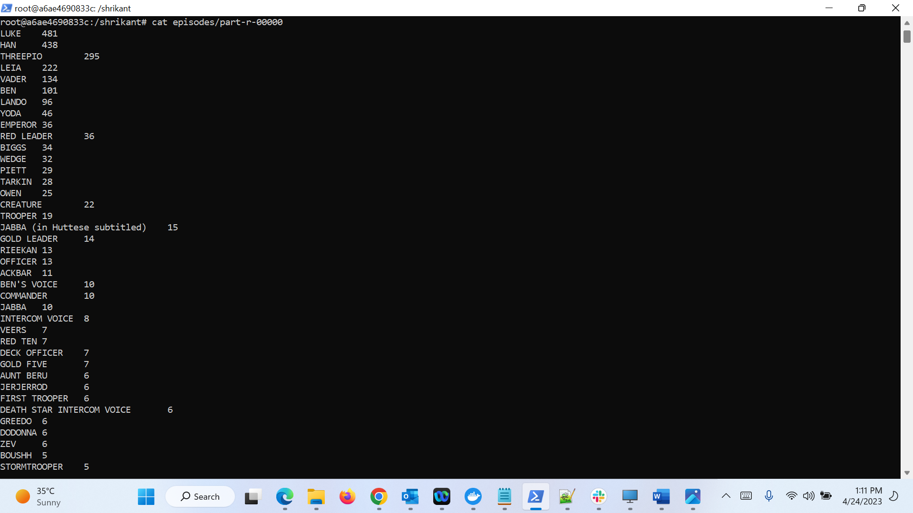

-- Load data from HDFS

ep4 = LOAD 'hdfs:///user/pigActivity/episodeIV_dialouges.txt' USING PigStorage('\t') AS (characher:chararray, line:chararray);

ep5 = LOAD 'hdfs:///user/pigActivity/episodeV_dialouges.txt' USING PigStorage('\t') AS (characher:chararray, line:chararray);

ep6 = LOAD 'hdfs:///user/pigActivity/episodeVI_dialouges.txt' USING PigStorage('\t') AS (characher:chararray, line:chararray);

-- Filter out the first 2 lines

ep4_ranked = RANK ep4;

ep4_OnlyDialouges = FILTER ep4_ranked BY (rank_ep4 > 2);

ep5_ranked = RANK ep5;

ep5_OnlyDialouges = FILTER ep5_ranked BY (rank_ep5 > 2);

ep6_ranked = RANK ep6;

ep6_OnlyDialouges = FILTER ep6_ranked BY (rank_ep6 > 2);

-- Combine the 3 episodes

dialogues = UNION ep4_OnlyDialouges, ep5_OnlyDialouges, ep6_OnlyDialouges;

-- Group by characher

groupByName = GROUP dialogues BY characher;

-- Count the number of lines by each character

charachers = FOREACH groupByName GENERATE $0 as characher, COUNT($1) as no_of_lines;

charachersOrdered = ORDER charachers BY no_of_lines DESC;

-- Remove the outputs folder

rmf hdfs:///user/ pigActivity/episodes/resultsNew

-- Store result in HDFS

STORE charachersOrdered INTO 'hdfs:///user/ pigActivity/episodes/resultsNew' USING PigStorage('\t');

HDFS

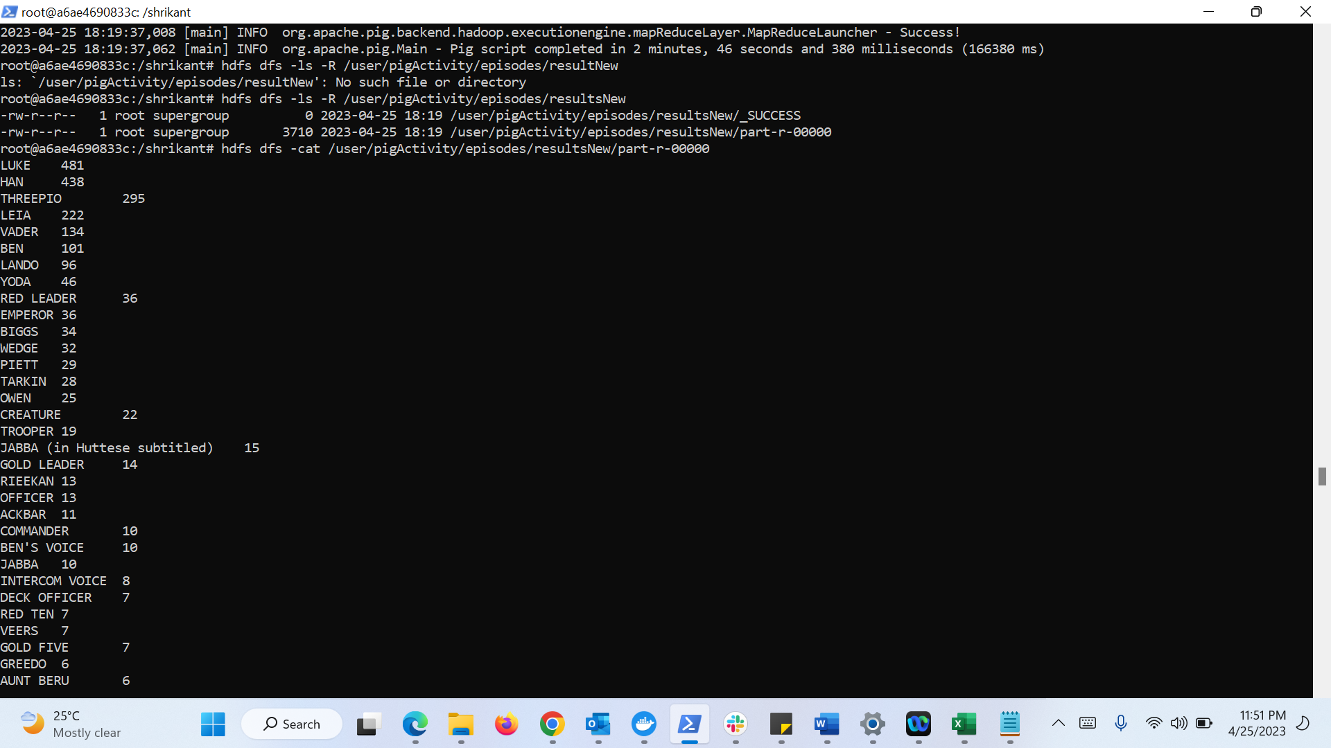

local 